1. Loading the Dataset



1. Use Polars to compute the Summary Statistics



1. Create at least two visualizations with Plotnine

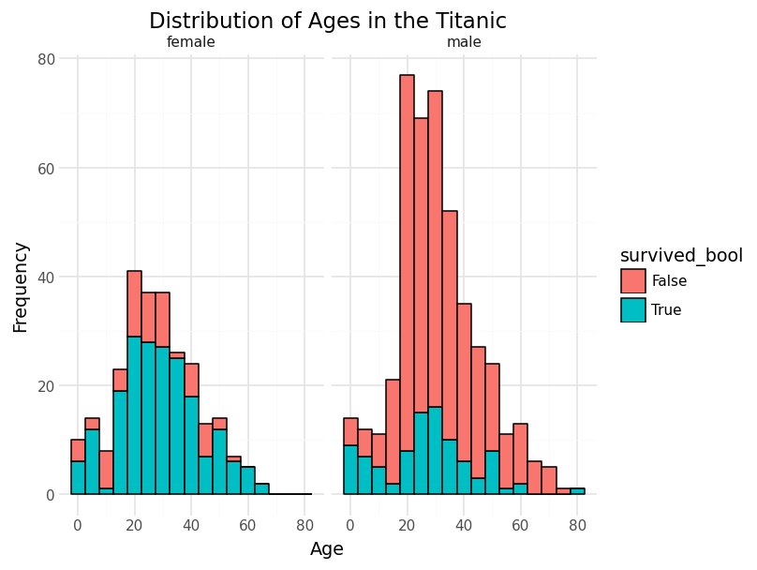

This indicates that females of all ages have a significantly higher rate of survival than males.

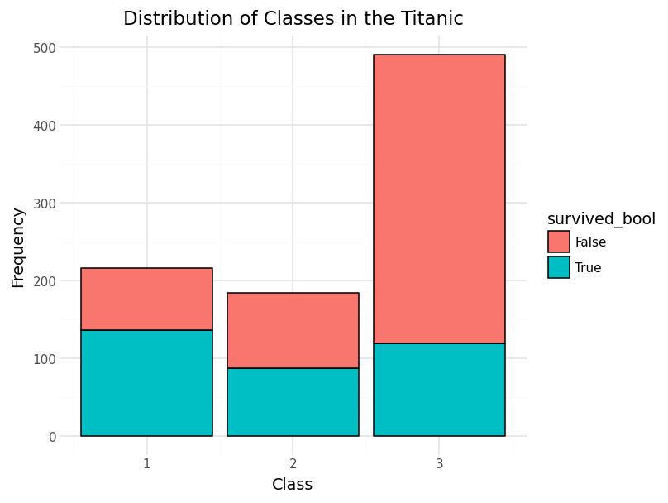

This plot indicates that the passengers of the 1st class have a higher chance of survival than the third class. Similarly, though there is a higher amount of survivors among the 3rd class, this may be due to the population imbalance among the 3rd class and the remaining 1st and 2nd class. Overall, this shows an increase in survival rate the higher the passenger class is.

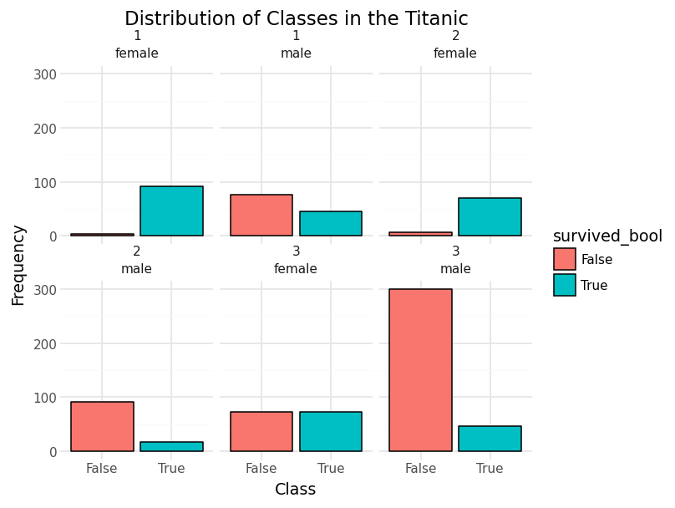

This is the combination of the first and second plots found above.

1. Interpret findings in 2-3 sentences (Explain which characteristics a person must have to survive the titanic)

Overall, we can derive that people who are female, regardless of the class have the highest rate of survival. Whereas if you are a male, you are most likely to survive if you are of the first class, other classes for males have a increasingly lower rate of survival compared to being a female.